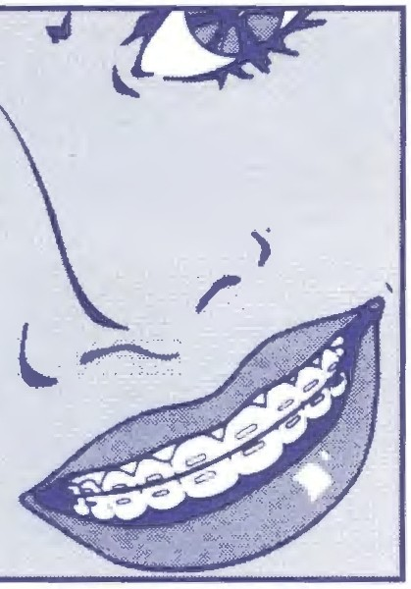IOUIS C. f lLIPPON E, D.D.S., P.C.
L O R T H O D O N T I S T
· ·

CENTREVILLE (703) 815-0127
GAINESVILLE (703) 754-4880
'

ORAL HYGIENE INSTRUCTIONS FOR ORTHODONTIC PATIENTS

- Brush 3-5 times a day for 2-3 minutes in a circular motion and carefully remove all food particles and plaque.

- BRUSHING ONCE OR TWICE A DAY IS INSUFFICIENT!

- Looking in the mirror as you brush your teeth.

- Pay close attention to the gum areas.

- Electric toothbrushes may be used instead ofregular toothbrushes.

- Brush all surfaces of your teeth including areas under the wires and around the braces and bands.

- Use a good fluoride toothpaste.

- Floss daily using your floss threaders.

- Failure to brush and floss properly may lead to stained or decayed teeth and gum problems.

- Never leave food or plaque on your teeth or braces.

- Continue to visit your dentist every 6 months for routine exams and cleanings.

